Computing Coursework 2 – Solving engineering problems with a programming language
Name: Daniel Newington
Student ID: 20726769

Add the relevant parts to the various sections below. Once complete, add this document to the .git repository and submit it together with your code, text files and functions.

Task 1 – read temperature data, plot, and write to a log file
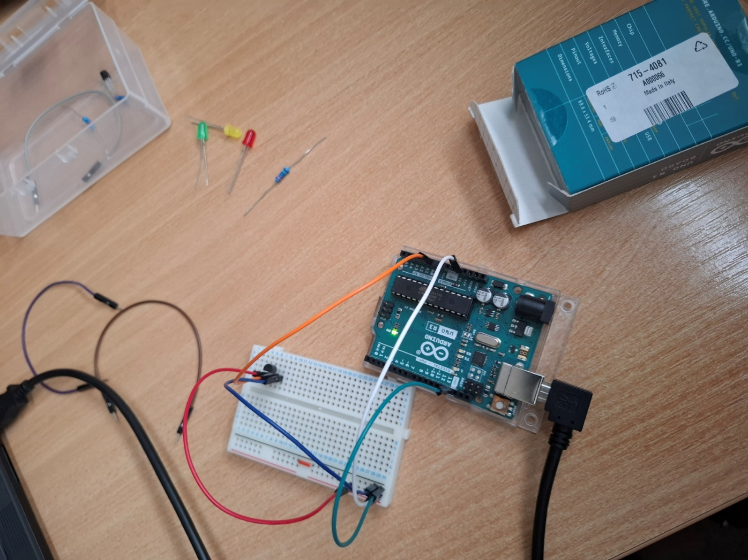
- Include a photograph of the implementation here.

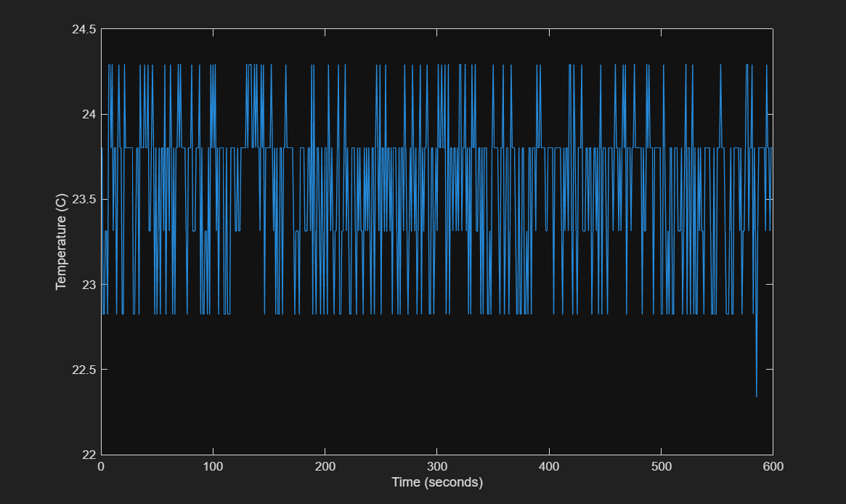
- Include the plot as an image here.

TASK 2 – LED temperature monitoring device implementation
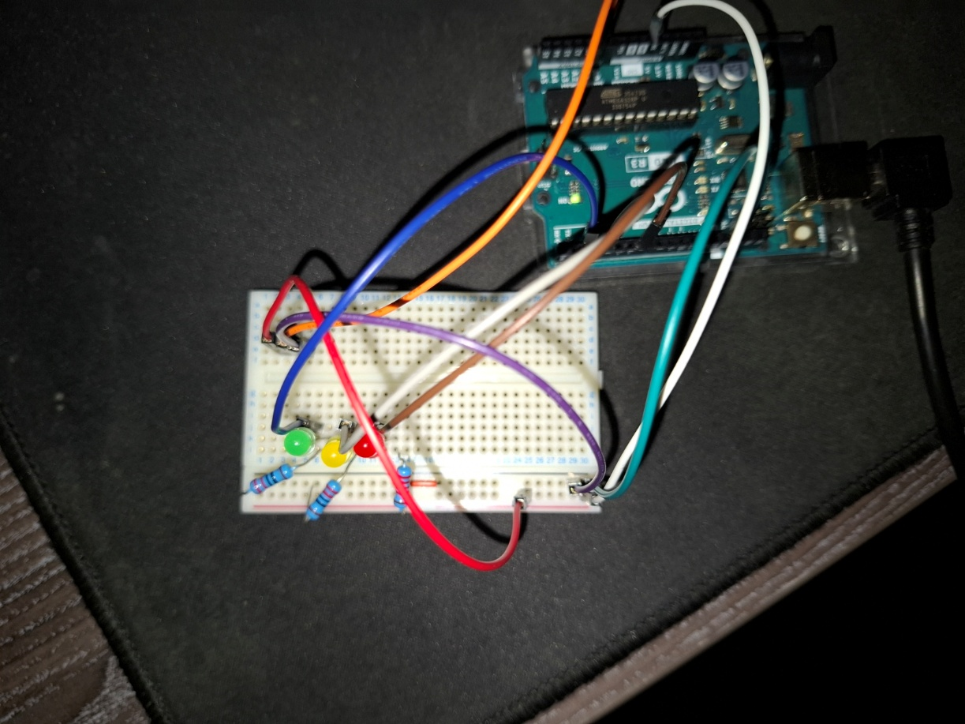
- Include a photograph of the implementation here.

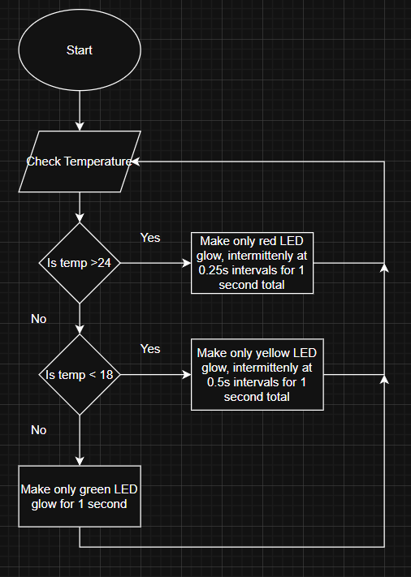
- Include your initial flowchart here.

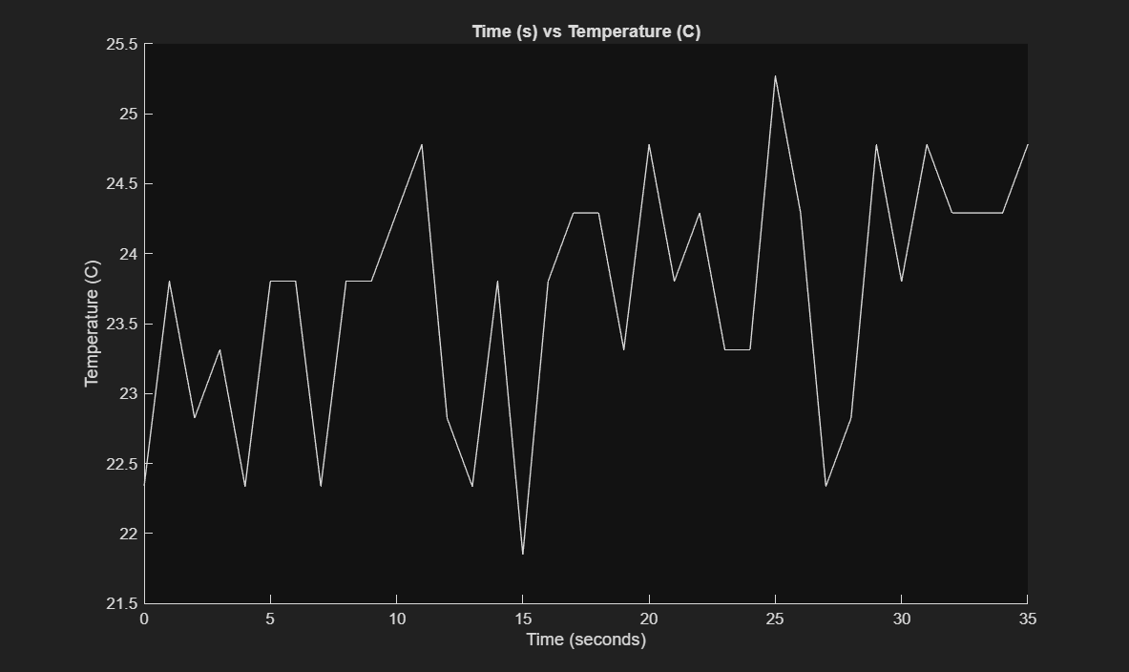
- Include the plot as an image here.

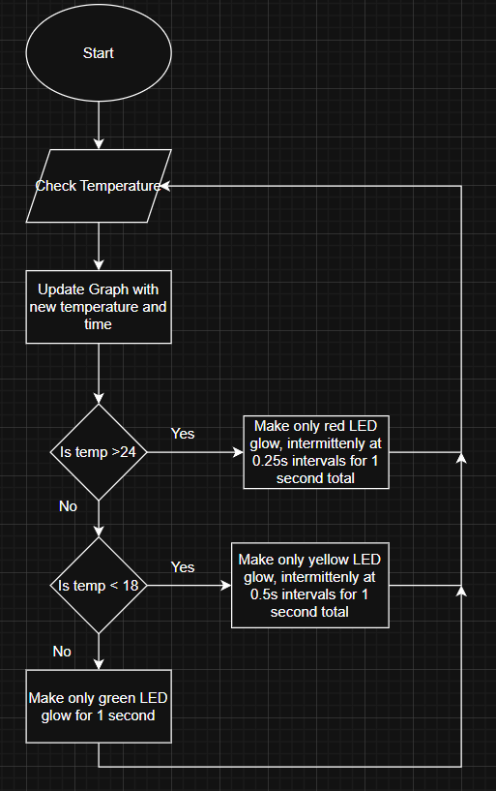
- Include your final flowchart here.

TASK 3 – ALGORITHMS – TEMPERATURE PREDICTION
- Include your initial flowchart here.
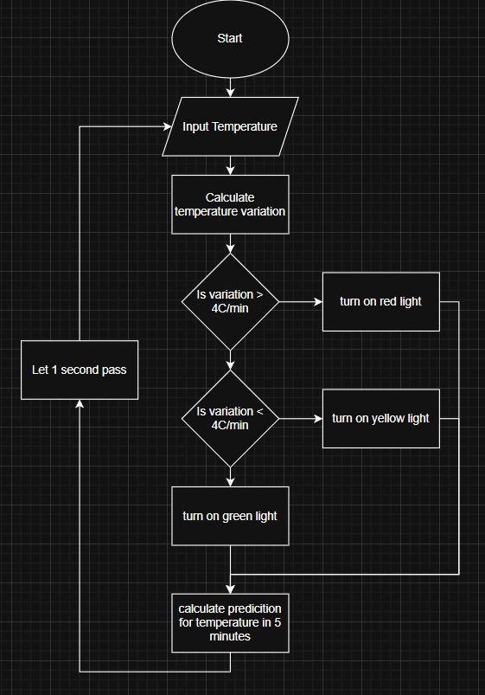

Task 4 – reflective statement
- Add your reflective statement here.
Some challenges I faced was trying to find an accurate and satisfying way of using the data to create the 5 minute prediction and deciding what would be an outlier or not, I think it was a strength that I went for a statistical approach as initially I had just a number deciding if it the value could be a multiple of mean, so in that sense I would want to improve that code in Q3, as well because it checks all the data when compiling the average and the spread, which is not as useful as medium term data would have been. For Q2 I had initially tried to find a way of continuously checking the temperature and have the LEDs run in the background, but I could not figure this out, so in the future I would want to improve this as currently the code limits the temperature readings to one every second, and this would also allow the LEDs to change more often to be more accurate to the current value of the current temperature. I think there were also limitations with the hardware such as the thermistor, as this gave varying results, causing lots of noise and inconsistency in the data – hence my statistical approach for programming in Q3. I would also want to find a way to make my code more efficient such as in Q3 so that the temperature could be sampled more often, as this allows my statistical parts to gain more data points to properly validate the inputs from the thermistor, as currently it still takes some time from the start for the spread in the range of the predictions to decrease to what I would expect to be a reasonable amount. I believe my code in Q1 could also be more efficient but slightly handicapped by the constraints of the question, as I repeat almost identical code when displaying to the command window and inputting into the txt file.

